Orolia released a software update for SecureSync 2400. Customers can download this software update at no charge from the Orolia website. This software update will upgrade the unit’s system software to Version 1.4.1.
This update provides added benefits through new features, enhancements to existing functionality, as well as software fixes and security updates, as described in this document.
For your convenience, older legacy releases are also described in this document.

Table of Contents
Table of Contents 2
Version 1.4.1 3
Version 1.3.0 7
Version 1.2.2 10
Version 1.2.1 11
Version 1.2.0 12
Version 1.1.0a 15
Version 1.0.2 16
Which SW version is installed on my SecureSync? 17
How to download and install the new SW 18
How to contact Technical Support 19

Version 1.4.1
Notes
- CAUTION: The 1.4.1 software does not allow downgrading. After applying this upgrade bundle, the unit cannot switch to an earlier version of the software without being returned to Orolia for reprogramming.
- This software version will upgrade BOTH system partitions to version 1.4.1 in order to solidify significant system changes. Future standard upgrade files will only upgrade one partition at a time.
- Some upgrade scenarios may cause a loss of user settings. See the Known Issue Upgrade warnings for loss of or altered configurations for more information.
Newly released features
- Added support for downgrades and software rollback. This feature alters the file formats of the upgrades (from .tar.gz to .squashfs) and has important effects:
  - When upgrading from any earlier software version, you are REQUIRED to first upgrade to version 1.4.1 in order to move to a later version.
  - Users will be able to use the “rollback” feature following this software update; however, the rollback feature will simply switch to the simultaneously installed version of this software extant within the other partition.
  - All subsequent software versions will allow downgrading to this version, but will not allow customers to go below 1.4.1.
- Added support for Linux PTP profiles IEEE C37.238-2017 (power systems profile) and IEC 61850-9-3:2016 (power utility profile).
- Added support for the ED25519 host key algorithm for SSH.
- Added software support for DC fixed and Hot Swap power supply options.
Enhancements and fixes
The following improvements were applied to existing features and functions:
- Added missing journal logging for pin configuration, network settings, and NTP and PTP configuration changes.
- Added statistics database to log bundles.
- The Authentication logging option was added to the Local Logging panel of the Web UI to allow user configuration.
- Improved the performance and stability of network timing.
- Set System Time Message, Daytime Protocol, and Time Protocol settings to default to OFF. Configuration enabling these features will persist through this upgrade.
- Added the ability for the user to reset PTP statistics.
- Improved Web UI behavior for PTP configuration.
- Created a Major Hardware alarm in the event of the Hot Swap Power Supply failure. This alarm will also be triggered if you disconnect or unplug, but do not remove, a power supply sled.
- Implemented the FP_lock and FP_unlock CLI commands to effectively lock and unlock the front panel.
- Added support for updated hardware (version 2) on the 1204-50 card.
The following defects were corrected:
- Fixed the Known Issue: When configured as a slave, the on-unit PTP will sometimes incorrectly remain in a Sync state when the Master has gone out of sync (found in 1.3.0).
- Fixed the Known Issue: The 4A/49 option card user configurations will be lost when performing an upgrade that is not “clean”. The card can be reconfigured and will function, but any new configuration will not persist after a power cycle of the unit. Cleaning the unit configuration (or performing a clean upgrade) will allow new configuration to persist correctly. An applied configuration bundle saved from an earlier software version will encounter the same difficulty (found in 1.3.0).
- Fixed the Known Issue: Any changes to the Logging Configuration (for instance, turning on Local Logging) will not take effect without restarting the unit (found in 1.3.0).
- Fixed the Known Issue: If a user configures the time zone via the front panel, the configuration will be lost after upgrade or config bundles are applied (found in 1.3.0).
- Fixed the Known Issue: The Reference Priority configuration is sometimes not restored properly from configuration bundles and will have to be reconfigured following upgrades or application of a config bundle from pre-1.3.0 software (found in 1.3.0).
- Fixed the Known Issue: When multiple major or minor alarms are present, the front panel LED alarm status light will not activate. All other alarm behavior, including notifications, operates as expected (found in 1.3.0).
- Resolved network timing and communication performance issues with the Belfuse SFP-1GBT-05 in ETH1.
- Limited simultaneous UI selection of QZSS with incompatible GNSS signals in order to prevent cross-correlation.
- Corrected an issue occurring when changing certain network settings that required resetting DHCP to resolve.
- Fixed a Web UI 500 error seen when setting the default network interface for IPv6.
- Fixed a Web UI issue that allowed users to incorrectly set the PPS source field for ASCII inputs delivered through the 15-pin connector.
- Edited Web UI settings to correct outdated branding.
- Repaired an issue with the detection of the General Purpose Output being incorrectly identified as a Square Wave output.
- Corrected a Web UI error providing users with an incorrect “pulse width” field which does not apply to 1PPS and 1PPM Output modes.
- Fixed an issue with the pin matrix failing to reset on a clean upgrade.
- Fixed a rare error with Rubidium oscillators in which the disciplining was incorrect.
- Resolved an omission in the Web UI upgrade log in which upgrade validation failures were not displaying correctly.
- Fixed a problem with the receiver mode reporting incorrectly.
- Corrected a minor issue with ZDA NMEA message type displaying on the front panel when used with ASCII output.
- Repaired Web UI issue not correctly displaying the 1204-4A and 1204-49 cards.
- Repaired a few minor errors occurring in the rare circumstance that the reference table is fully emptied by the user.
Security enhancements and fixes
- Applied small patch to kernel to mitigate the Dirty Pipe vulnerability (CVE-2022-0847).
- Removed support for the SSH DSA algorithm due to insufficient key length. Customers are advised to use RSA or equivalent. (DSA configuration will not be removed upon update or while in use unless the user deletes the configuration).
- Added a console (serial) port connection timeout (60 minutes).
- Enhanced the REST API security by verifying the user’s privilege at expected points in order to limit tampering.
- Limited access to databases without full REST API credentials.
- Fixed an error with HTTPS certificate generation in which the Organization and Organization Unit fields were flipped.
Option Card enhancements and fixes
- Option cards 1204-49 and 1204-4A have been upgraded to version 1.1.2
  - Fixed configuration loss after upgrade.
- Corrected an issue with the 1204-2F Programmable Frequency card reverting to default settings following unit reboot.
- Fixed a problem with the 1204-32 PTP Grandmaster card IP settings being lost on reboot.
- Added a user field for the 1204-3E STL card to enter a time offset to compensate for system or antenna cable delays.
Known Issues
- Option cards 1204-49 and 1204-4A are limited to install on slots 1 & 2 only.
- This software version DOES NOT ALLOW downgrades. If you put this software on your system, and later need to return your unit to a software version that came before version 1.4.1, it will be necessary to return your unit to Orolia for reprogramming (from 1.3.0).
- ASCII time code format ICD-153c is supported only on the -02 and -1F option cards, and only if the unit has a SAASM receiver installed. This format is not supported on the main board interface (from 1.3.0).
- The clean command does not reset the GNSS position. It is recommended to unplug the receiver, reset the receiver in the Web UI, and then run the clean command in order to reset the GNSS position (from 1.3.0).
- PTP over a VLAN interface is not currently functional.
- The SFP fiber link-state on models AVAGO AFBR-5710PZ and FTLF8519P2BNL are not working properly.
- The restore factory defaults function clean does not currently reset the Network Access control rule.
- Upgrade warnings for loss of or altered configurations:
  - On software versions before 1.3.0, SNMP, GPSD, and LDAP settings are preserved on upgrade but not correctly transferred in configuration bundles. These services will need to be re-enabled following the application of a configuration bundle.
  - On software versions before 1.3.0, certain front panel settings for the Local Clock and the Lock Keyboard function do not persist after upgrade.
  - Upon upgrading to 1.4.1 or applying a configuration bundle from an earlier version, the System Time Message feature will be set to ON, regardless of previous setting. Following a Clean upgrade to 1.4.1, the System Time Message, Daytime Protocol, and Time Protocol features will be configured to OFF (the new default state).
  - If your current software is on 1.1.0a or earlier, a direct upgrade to 1.4.1 will fail unless the clean option is selected. To prevent configuration loss, users are advised to save a configuration bundle, perform a clean upgrade to 1.4.1, and apply the saved config file.
- PTP Power Profile (IEEE C37.238) is unable to pass the Alternate Time Offset Indicator and Total Time Inaccuracy TLVs through the system when PTP interfaces are configured as both a master and a slave.
- PTP Power Profile (IEEE C37.238) is only able to sync to an EdgeSync master when set to mixed Unicast mode.
- The tcpdump command functionality was found to have incorrect ownership, thereby preventing users from deleting files, even with admin rights. To remove these files, the user can update to the same or a newer version. To prevent this scenario, you can execute tcpdump as sudo tcpdump -Z <user> ..., (for example: sudo tcpdump -Z spadmin -i eth0 -w file.pcap). This will cause the captured file to be created with ownership of the specified user, allowing said user to delete the file.

Version 1.3.0
Notes
- CAUTION: The 1.3.0 software does not allow downgrading. After applying this upgrade bundle, the unit cannot switch to an earlier version of the software without being returned to Orolia for reprogramming.
Newly released features
- Improved the on-unit PTP functionality. PTP now has an updated software subsystem, more PTP profile options, and supports both Slave and Master configurations, Unicast, Multicast, and Hybrid settings, and both IPv4 and IPv6 connections.
- Enabled the use of the High Security HTTPS option to restrict the use of TLSv1.
- Standardized the REST API functionality and the documentation procedure for it. All future major changes to REST API endpoints will be documented in these release notes.
Enhancements and fixes
The following improvements were applied to existing features and functions:
- Upgraded several packages:
  - Updated the Linux kernel to 5.10.19
  - Upgraded Apache to 2.4.46
  - Upgraded NTP to version 4.2.8p15
  - Upgraded Openssl to 1.1.1j
  - Upgraded NetSWP to version 5.8
  - Upgraded OpenSSH to version 8.1p1
  - Upgraded PHP to version 7.4.15
  - Upgraded GPSD to version 3.23
NOTE: this upgrade contains a bug fix for the GPS week rollover issue on 2021-10-23.
- Improved the function of the clearlogs, clearstats, and clean commands in the Web UI.
- Improved the RADIUS, LDAP, and TACACS+ forms in the Web UI.
- Improved the user experience of the configuration page of the GP Output.

The following defects were corrected:
- Fixed the Known Issue: “In version 1.2.2, the 2400 cannot be configured to operate as both a PTP slave and NTP client.”
- Fixed the Known Issue: “When switching PTP configuration between master and slave, occasionally the change will not take effect unless manually disabling/reenabling PTP on that interface.”
- Fixed the Known Issue: “The following option cards are currently limited in use to only slots 1 & 2: 1204-2F, 1204-13, 1204-23, 1204-49, 1204-4A, and 1204-30.” Two option cards (1204-49 and 1204-4A) are still limited to install on slots 1 & 2 only. All other option cards are available for use in any slot.
- Fixed the Known Issue: “STANAG 4430 HVK EXTENDED EDITION 1 is not currently functional.”
- Fixed the Known Issue: “Units with more than four 1204-15 IRIG OUT cards installed at once may experience failures and difficulty with programming the outputs.”
- Improved Galileo configuration to follow ublox receiver recommendations.
- Resolved an error with the gpsreset command
- Corrected an issue with certain services (LDAP, GPSD) that were preserved on an upgrade but not during configuration bundle upload.
- Corrected an error in which the temperature alarm configuration was not properly transferred on upgrade.
- Added a missing timescale selection field in the IRIG Output configuration.
- Corrected the Signature Control functionality in GP Output configurations.
- Added a missing toggle to enable/disable the System Time Message.
Security enhancements and fixes
- Resolved compatibility with DHCP, IPv6, and TACACS+.
Option Card enhancements and fixes
- Option card 1204-4A upgraded to version 1.1.1.
- Option cards 1204-23 now available for use on all slots.
- 1204-32 Gb PTP Master Card had several improvements with the updated version 1.31 firmware
  - fixed inoperability with devices that use non-standard values for the PTP transportSpecific field
  - resolved an issue with PTP packets being broadcast before the unit is fully synchronized
  - changed generation of clockAccuracy parameter to reduce unnecessary transitions between Best Masters
  - fixed configuration of TTL value on PTP multicast announce packets
  - corrected the MAC address in Layer 2 PTP packets.
Known Issues
- Option cards 1204-49 and 1204-4A are still limited to install on slots 1 & 2 only.
- This software version DOES NOT ALLOW downgrades. If you put this software on your system, and later need to return your unit to a software version that came before version 1.3.0, it will be necessary to return your unit to Orolia for reprogramming.
- When configured as a slave, the on-unit PTP will sometimes incorrectly remain in a Sync state when the Master has gone out of sync.
- ASCII time code format ICD-153c is supported only on the -02 and -1F option cards, and only if the unit has a SAASM receiver installed. This format is not supported on the main board interface.
- The 4A/49 option card user configurations will be lost when performing an upgrade that is not “clean”. The card can be reconfigured and will function, but any new configuration will not persist after a power cycle of the unit. Cleaning the unit configuration (or performing a clean upgrade) will allow new configuration to persist correctly. An applied configuration bundle saved from an earlier software version will encounter the same difficulty.
- The clean command does not reset the GNSS position. It is recommended to unplug the receiver, reset the receiver in the Web UI, and then run the clean command in order to reset the GNSS position.
- Any changes to the Logging Configuration (for instance, turning on Local Logging) will not take effect without restarting the unit.
- If a user configures the time zone via the front panel, the configuration will be lost after upgrade or config bundles are applied.
- The Reference Priority configuration is sometimes not restored properly from configuration bundles and will have to be reconfigured following upgrades or application of a config bundle from pre-1.3.0 software.
- When multiple major or minor alarms are present, the front panel LED alarm status light will not activate. All other alarm behavior, including notifications, operates as expected.

Version 1.2.2
Enhancements and fixes
The following defects were corrected:
- Fixed a one second offset found in PTP synchronization between the master and slave.
- Corrected an issue with PTP slaves incorrectly reporting as in-sync despite no longer receiving messages from the master.
- Corrected an issue with PTP slaves incorrectly reporting as in-sync despite the designated master no longer being in sync.
Known Issues
- In version 1.2.2, the 2400 cannot be configured to operate as both a PTP slave and NTP client.
- When switching PTP configuration between master and slave, occasionally the change will not take effect unless manually disabling/reenabling PTP on that interface.

Version 1.2.1
Enhancements and fixes
The following defects were corrected:
- Fixed an issue with a memory leak when specific pages were viewed on the front panel. This includes pages viewed that timed out while open. This leak can be found in all previous software versions and is automatically cleared upon a reboot, including when updating to software version 1.2.1.
Known Issues
- The following option cards are currently limited in use to only slots 1 & 2: 1204-2F, 1204-13, 1204-23, 1204-49, 1204-4A, and 1204-30.
- On units that have manually-set time as a PTP Master and then are switched to using a valid reference, the Slave time does not correctly switch to the reference but will instead stay on manual time. If switching between manually-set time and an external reference, the PTP master must be restarted for the slaves to properly follow the new time source.
- When restoring configurations, the GNSS Constellations configuration is on rare occasions not loading correctly.

Version 1.2.0
*Amendment issued on 2021/11/4: Thermal control of the cooling fans was added in this release.*
Newly released features
- Updated front panel appearance and functionality to add visual indications of reboot, upgrade, and halt states, am/pm indicator light, front panel keypad lock, fan state, and to allow users to configure the time zone of seven segment display.
- Added support for the Hotswap Power Supply feature in the Web UI and on the front panel.
- VLAN is now supported.
- Implemented support for IPv6, including PTP, front panel, and Web UI support
- Enabled support of the SAASM GPS system via option card 1204-50.
- Added support for NTP over Anycast.
- Added GPSD support on units with commercial receivers
Enhancements and fixes
The following improvements were added:
- Added static routes by interface into the Web UI
- Added an option to broadcast PTP timestamps in UTC rather than TAI with an added offset.
- Added enhanced support when the unit is configured as an NTP client to allow close discipling of the oscillator.
- Enabled TACACS+ usernames and passwords to allow the “_” character
- Improved KTS host disciplining
- Upgraded the Linux kernel to version 4.19.120.
- Improved SFP functionality and reliability
- Removed faulty downgrade paths to earlier, non-standard versions. It will not be possible to downgrade past 1.2.0 from this point forward.
- Changed SNMP monitoring output messages in order to match the SecureSync 1200 functionality to accommodate customers with both systems.
- Allowed users to select SNMP port

The following defects were corrected:
- Fixed an issue wherein the NTP and PTP references were incorrectly handled through the Reference Monitoring chart in the Web UI.
- Corrected 1PPS and 10 MHz alignment
- Fixed a problem with errors on IRIG Outputs.
- Repaired routing to allow destination-based addressing
- Repaired an issue with the GNSS config file sometimes not saving correctly
- Fixed an error with phase validation reference monitoring.
- Resolved a problem occurring when manually set time was removed but the system did not resync to correct references.
- Fixed an issue with the command clearlogs causing a break in the NTP stats recording process
- Corrected a defect with log rotation functionality that caused potential storage problems.
- The net4 command now no longer returns Interface not Activated
- Repaired MTU settings changes in the Web UI
- Fixed a problem in which the listed event times in the Web UI were incorrectly displayed.
Security enhancements and fixes
- Addressed CSRF vulnerabilities related to POST/GET Restful functions
- Removed FTP support to allow for greater security (via SFTP)
Option Card enhancements and fixes
- Added support for option cards 1204-0A, -0F, -03, -09, -1F, -14, -40, -41, -42, -49, -50.
- Upgraded firmware version on the following option card:
1204-4A and 1204-49 cards to version 1.1.0.
Released version 1.31 for option card 1204-32
1204-10 upgraded to 1.03
1204-14 upgraded to1.02
1204-15 upgraded to 1.12
1204-1B upgraded to 1.04
1204-1E upgraded to 1.03
1204-22 upgraded to 1.03
1204-28 upgraded to 1.02
1204-34 upgraded to 1.01
- Added a field in the Web UI to allow the addition of an offset value to the output of the 1204-02 card

The following defects were corrected:
- Corrected a known issue in which the 1204-4A card configuration was not properly transferred through the config bundle.
Known Issues
- Units with more than four 1204-15 IRIG OUT cards installed at once may experience failures and difficulty with programming the outputs.
- STANAG 4430 HVK EXTENDED EDITION 1 is not currently functional.
- An issue exists with DHCPv6 not setting up valid subnet routes.

Version 1.1.0a
Enhancements and fixes
The following improvements were added:
- Added support for the Interference Detection & Mitigation Suite
- Added support for the 4A option card.
- Enabled PTP on both Ethernet ports.
- Created High Security HTTPS option
- Added LED blinking support for the front panel menu buttons to provide status indicators
- Implemented TACACS+, RADIUS, and LDAP security functionality.
- Inserted the latest version of the pdf User Manual directly to the Web UI.
- Improved clarity over GNSS selection combinations.
- Increased the size of the reference table beyond 16 entries.
- Added the clearcfg command to clear configurations but retain log information.

The following defects were corrected:
- Fixed an issue wherein the NTP status page did not display client throughput.
- Repaired a problem with ASCII Input Time validity in the GGA format.
- Corrected front panel problems: a difficulty displaying leap seconds, a problem halting and clearing configurations, an issue with disabling output through the front panel, a problem with the display of the IP address, and added a front panel test menu.
- Fixed a few minor Web UI errors involving display of option cards
- Repaired a few CLI command issues with the clean command, between IPv4 and IPv6 commands, portset/ portget, and gw4set/ gw6set. Confirmed consistency of CLI commands and underlying network configuration functions.
Security enhancements and fixes
- Added Web UI security features to prevent login simultaneously from multiple locations and mitigate brute force password attacks.

Version 1.0.2
Enhancements and fixes
The following defects were corrected:
- Fixed an issue with Rubidium units skipping the warmup fix.
Security enhancements and fixes
- No major vulnerabilities are currently known or repaired in this release.

Which SW version is installed on my SecureSync?
To determine the software version currently installed on your unit:
- Login to the unit’s Web UI
- Navigate to Tools > Upgrade/Backup. The System Configuration panel in center of the screen displays the current version number under System:

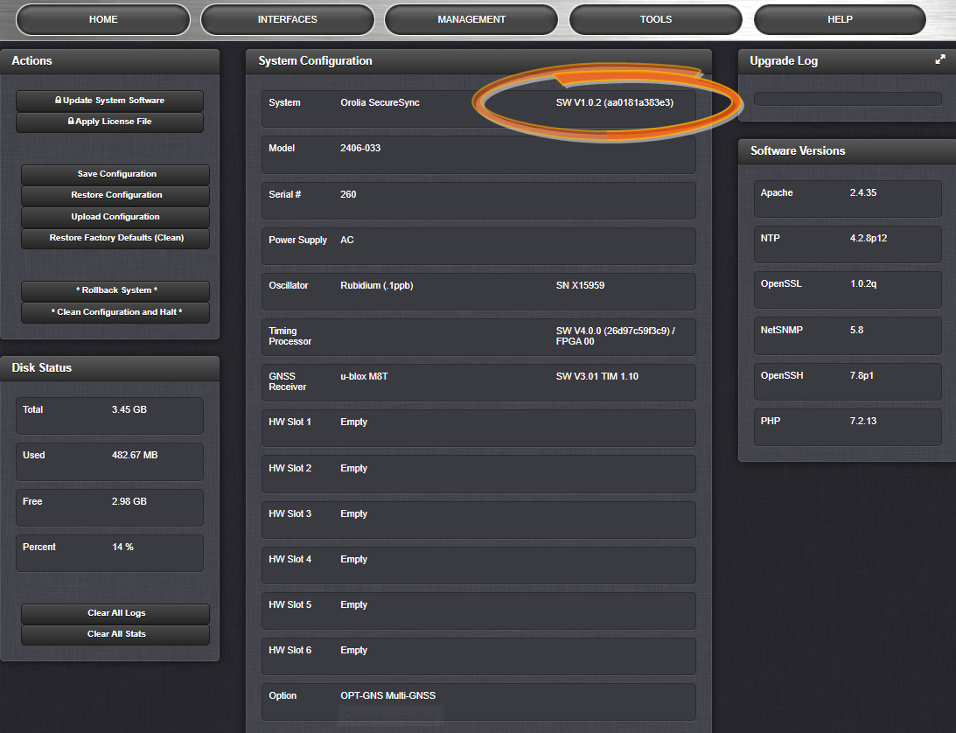
Figure 1: Software revision reported under Tools > Upgrade/Backup.

How to download and install the new SW
Installing the Software Update
To upgrade the software installed on your unit, download the latest version from the Orolia website: files.spectracom.com/downloads/24xx
Log on to the Web UI and navigate to Tools > Upgrade/Backup and click on Update System Software in the Actions panel.
Click the Choose File button and select the upgrade file location; click Upload.
Click the Perform Upgrade checkbox. If desired, select the Clean Upgrade checkbox as well.
Click on the Submit button. The upgrade will begin immediately. The unit will reboot during this process; it will be necessary to begin a new Web UI session.

For more information on this process or any other feature or function of the SecureSync 2400, refer to the main user manual.

How to contact Technical Support
Should you have any questions or comments regarding any of the above-mentioned features or fixes, please contact Technical Support:
https://www.orolia.com/support/
- End of document -

